# Kuakata Sea Beach: The Daughter of the Sea

*Kuakata*, often referred to as the "Daughter of the Sea," is a spectacular sea beach located in the southernmost part of Bangladesh, in the Patuakhali district. Known for its breathtaking panoramic views of both sunrise and sunset, Kuakata stands out as a rare natural wonder and a must-visit destination for travelers seeking peace, beauty, and a touch of adventure.

## A Scenic Beauty of Nature

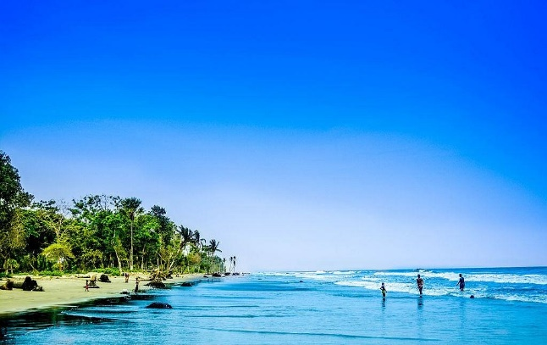*Kuakata* spans approximately 18 kilometers along the Bay of Bengal and offers a unique combination of unspoiled sandy beaches, tranquil waters, and lush green landscapes. The beach is famous for its wide shoreline, where the sea breeze is ever-refreshing, and the horizon seems to stretch endlessly. Its name originates from the word *‘kua’*, meaning well, as the early settlers, the Rakhine people, dug wells to source drinking water.

*Scenic Beauty of Nature*

## Why Visit *Kuakata*?

1. 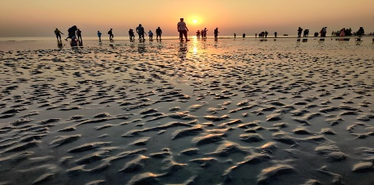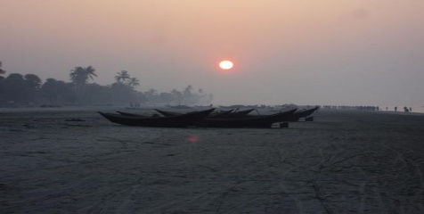Sunrise and Sunset Views:  
   *Kuakata* is one of the few places in the world where visitors can enjoy uninterrupted views of both sunrise and sunset over the ocean.

*Sunrise*  *Sunset*

The serene beauty of the early morning sun rising above the calm waters and the fiery hues of sunset merging with the waves is mesmerizing.

1. Cultural Experience:  
   *Kuakata* is rich in cultural diversity, with a significant presence of the Rakhine community. Visitors can explore their lifestyle, try traditional dishes, and shop for hand-crafted items like vibrant textiles and pottery.
2. Buddhist Heritage:  
   The region is home to ancient Buddhist relics and temples, such as the *Misripara Buddhist Vihara* and *Kuakata Seema Mandir*. These are spiritual hubs and offer a peek into the area's historical significance.
3. Adventure and Activities:  
   *Kuakata* offers a mix of activities for all types of travelers. From beachside walks, cycling, and fishing to boat rides and exploring mangrove forests nearby, there's no shortage of things to do. The adventurous can explore the Gangamati Reserved Forest and observe unique plant species and wildlife.
4. Festivals and Events:  
   The Rakhine community celebrates colorful festivals like *Maghi Purnima*, which includes traditional boat races, fairs, and religious rituals, adding a vibrant touch to the Kuakata experience.

## Getting to *Kuakata*

*Kuakata* is about 320 kilometers from Dhaka. Travelers can opt for bus services or private vehicles to reach the destination. Waterway travel via launch and ferry services adds a unique twist to the journey. A well-developed network of roads ensures that even the journey itself is a memorable adventure.

## Best Time to Visit

The ideal time to visit *Kuakata* is during the winter months (November to February) when the weather is pleasant and conducive to beach activities. The cool breeze and moderate temperatures make it perfect for sightseeing and relaxation.

## Sustainable Tourism

Efforts are underway to promote sustainable tourism in *Kuakata*. Authorities and local communities are working to preserve its pristine environment, ensuring that the natural beauty and cultural heritage remain intact for future generations.

|  |  |
| --- | --- |
| Exercise Type | Benefit |
| Running | Improves cardiovascular health |
| Yoga | Increases flexibility and reduces stress |
| Strength Training | Builds muscle and bone density |

## Conclusion

*Kuakata* Sea Beach is more than just a destination; it is an experience that stays with you forever. Its serene environment, cultural richness, and natural beauty make it a hidden gem of Bangladesh. Whether you are looking for a quiet retreat, an adventurous getaway, or a chance to immerse yourself in a different culture, *Kuakata* is the perfect choice. Plan your trip, pack your bags, and let the "Daughter of the Sea" enchant you with her timeless charm.

## Reference:

# Works Cited

(Casselman & Tankersley, 2020-06-10)

# Bibliography

(ed.), R. B. (1892–1945). The Chicago Tradition in Economics ,. *Journal_of_Political_Economy*, 2.

Casselman, B., & Tankersley, J. (2020-06-10). "Economics, Dominated by White Men, Is Roiled by Black Lives Matter".